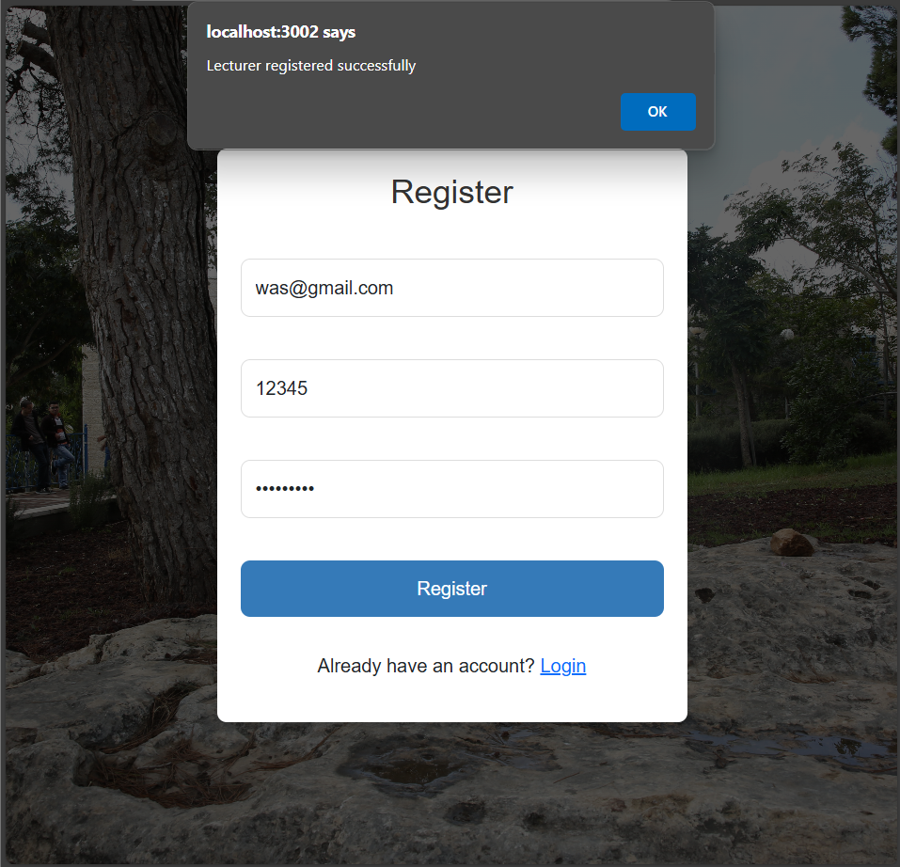

Create a new account

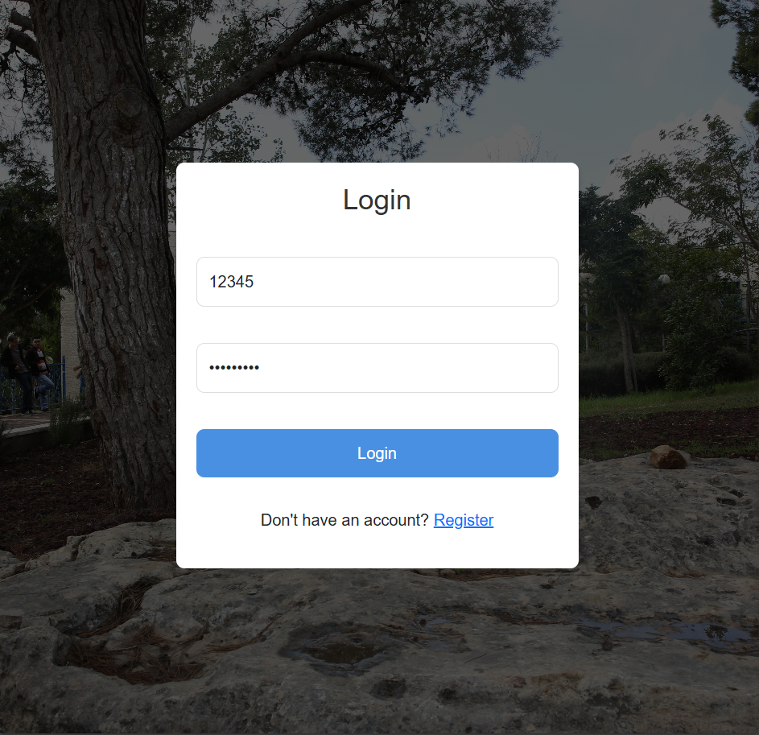

Account Login

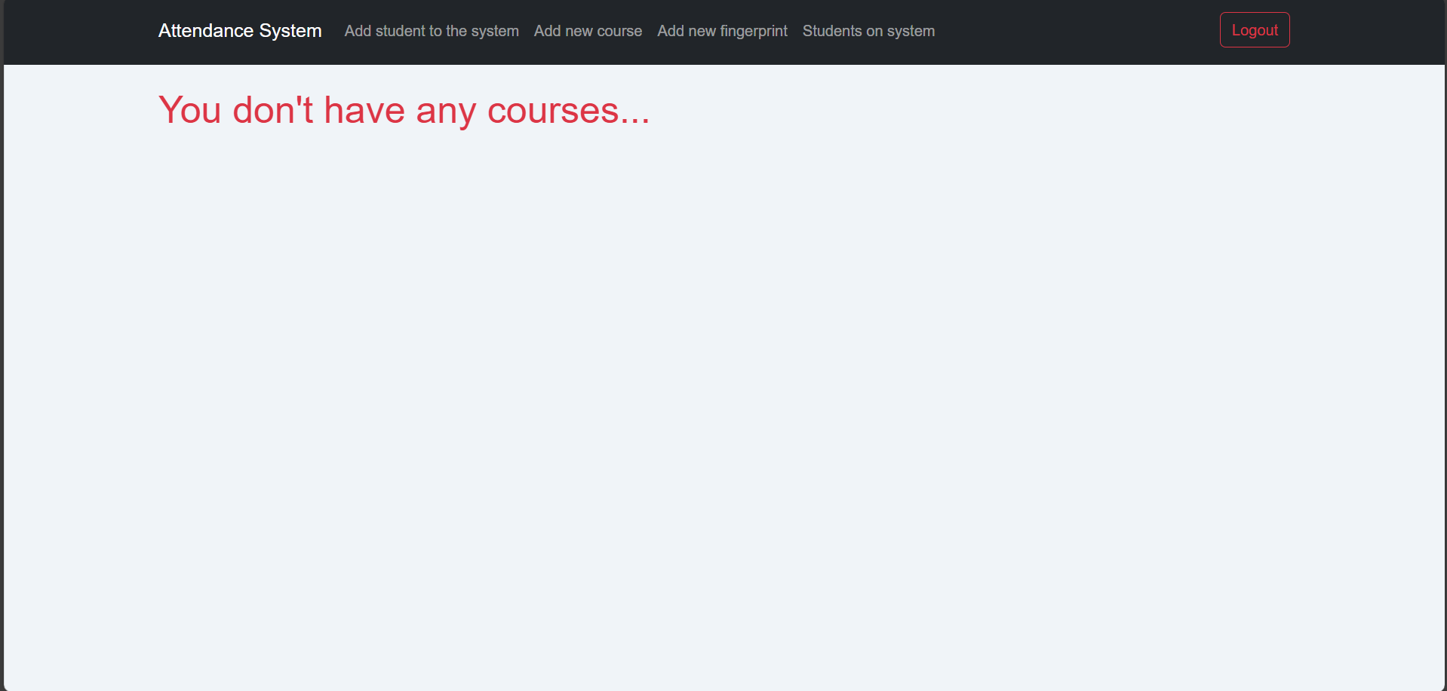

When you log in for the first time

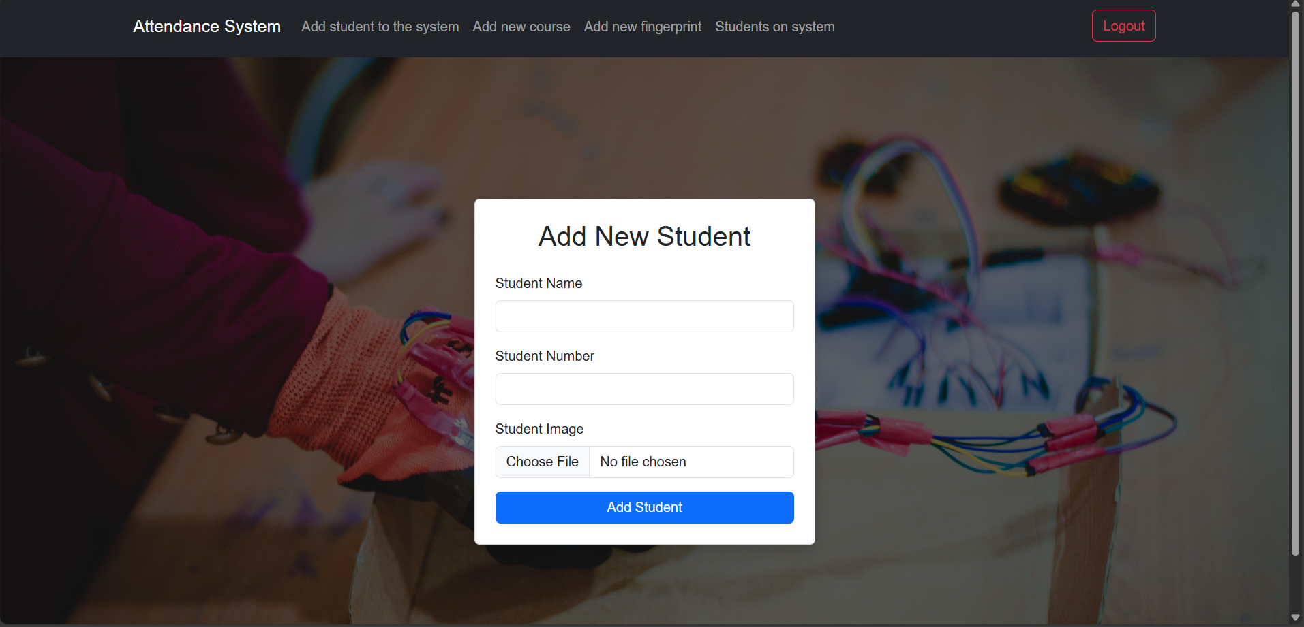

Adding students to the site (all colleges, for example)

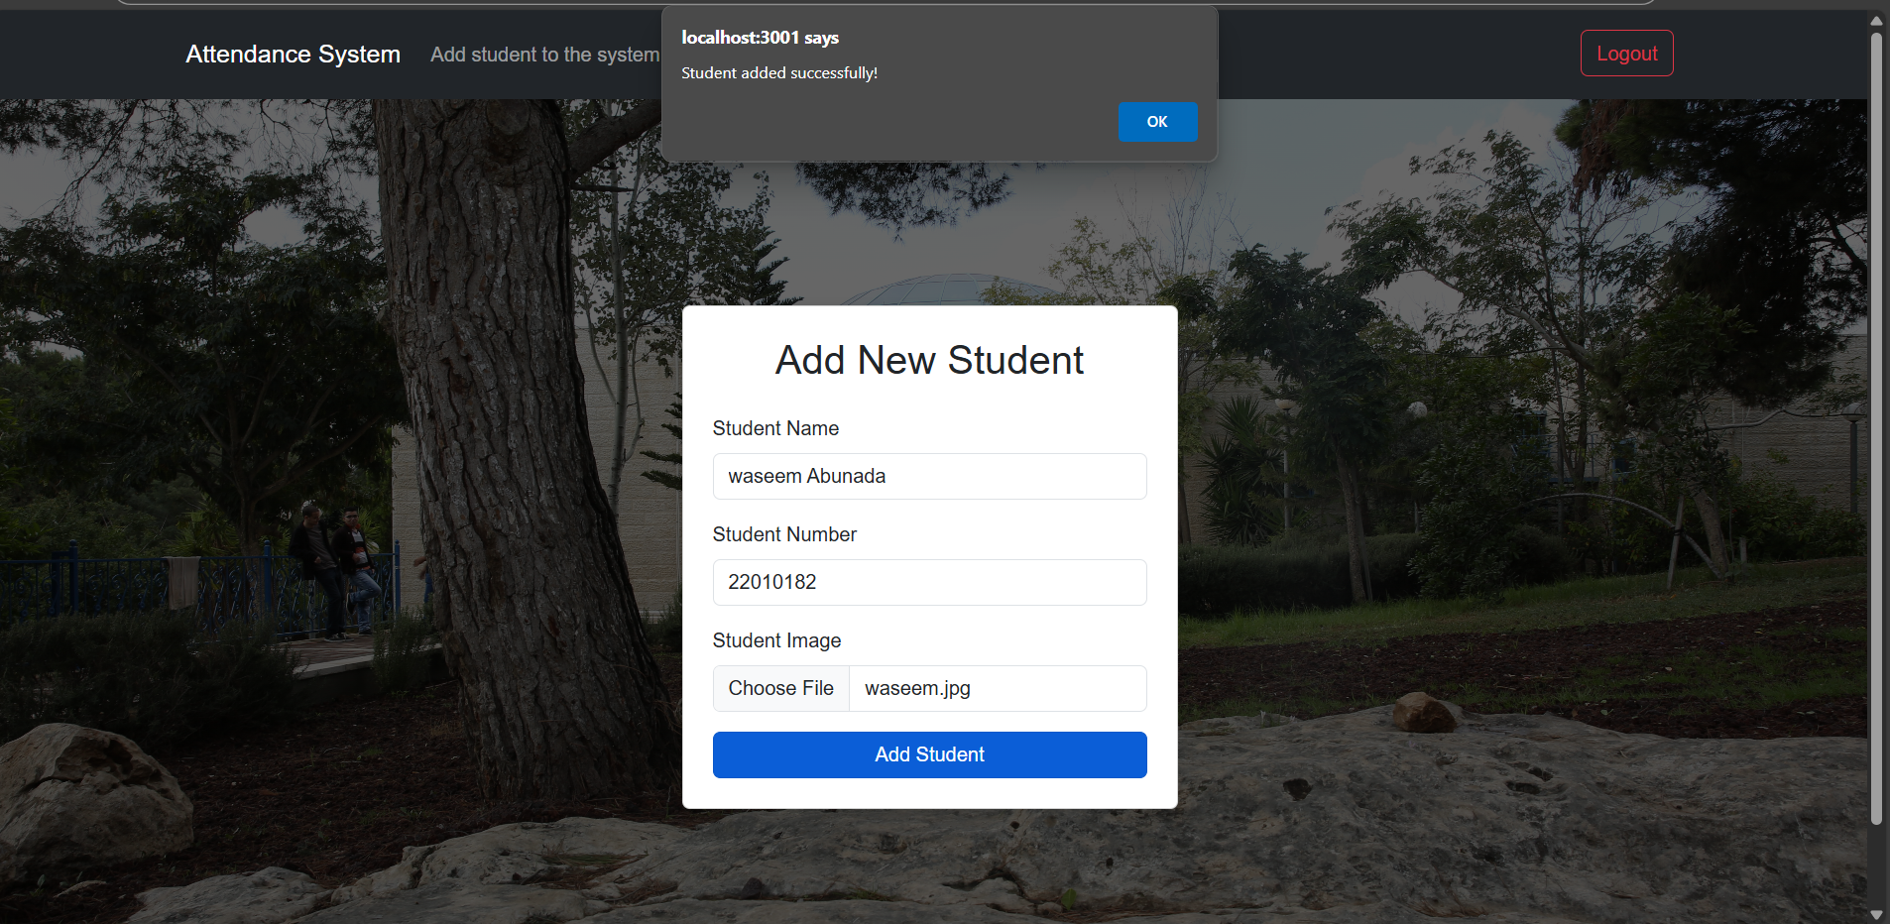

The student has been added successfully

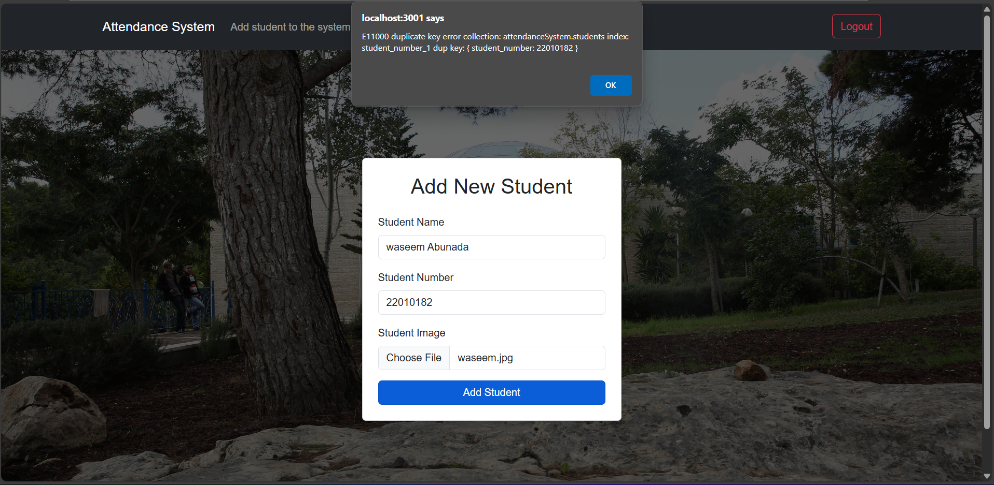

If the student has been added to the system before, it will not be repeated based on the university number

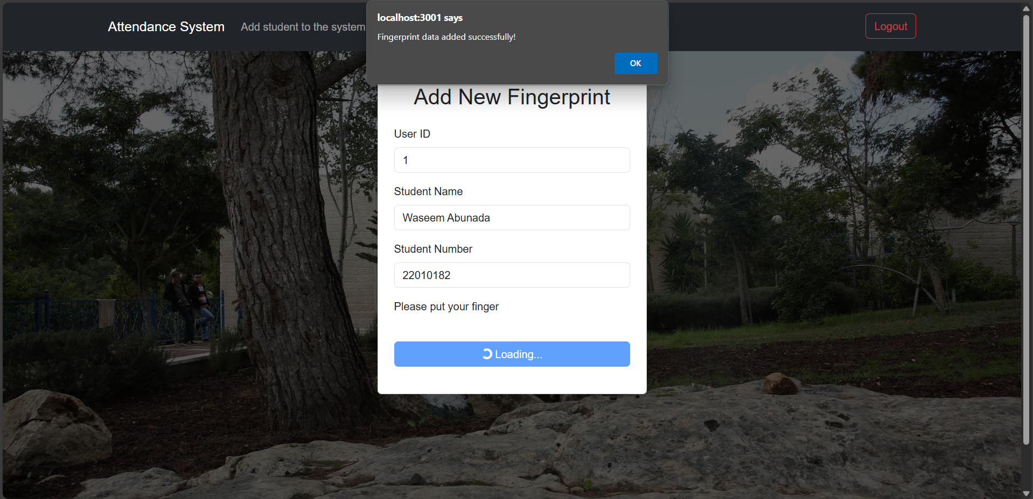

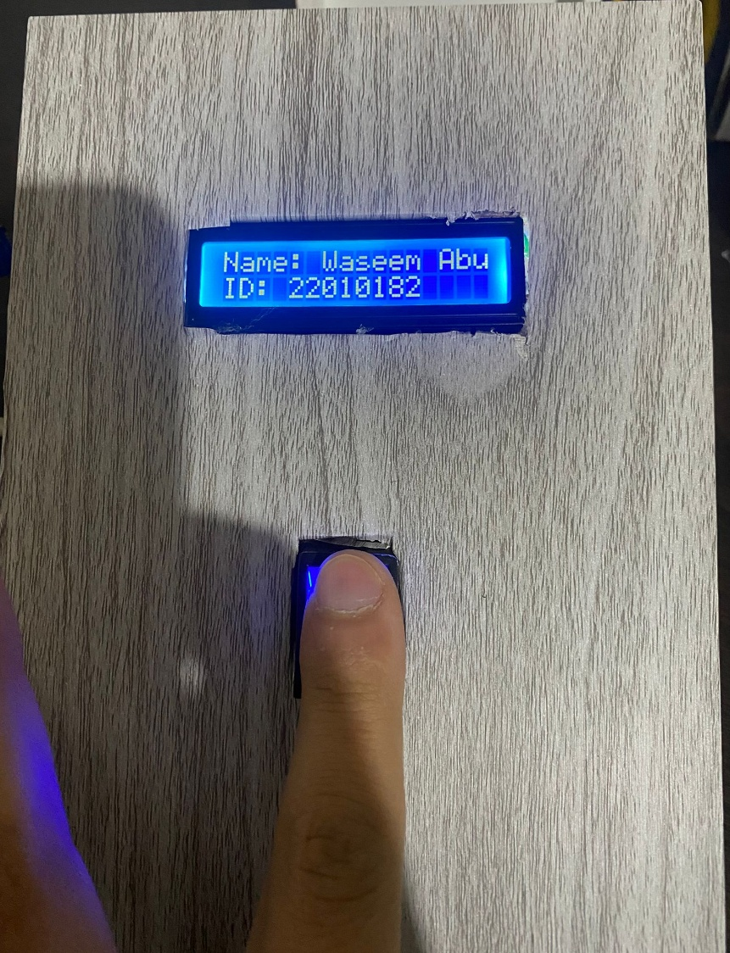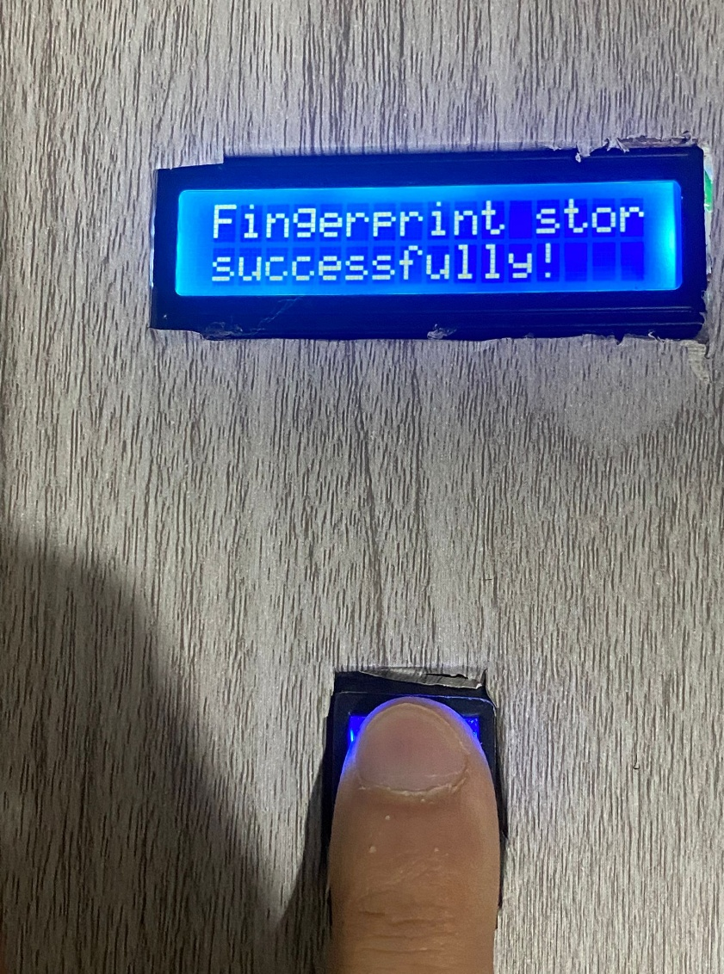Add a fingerprint for the student

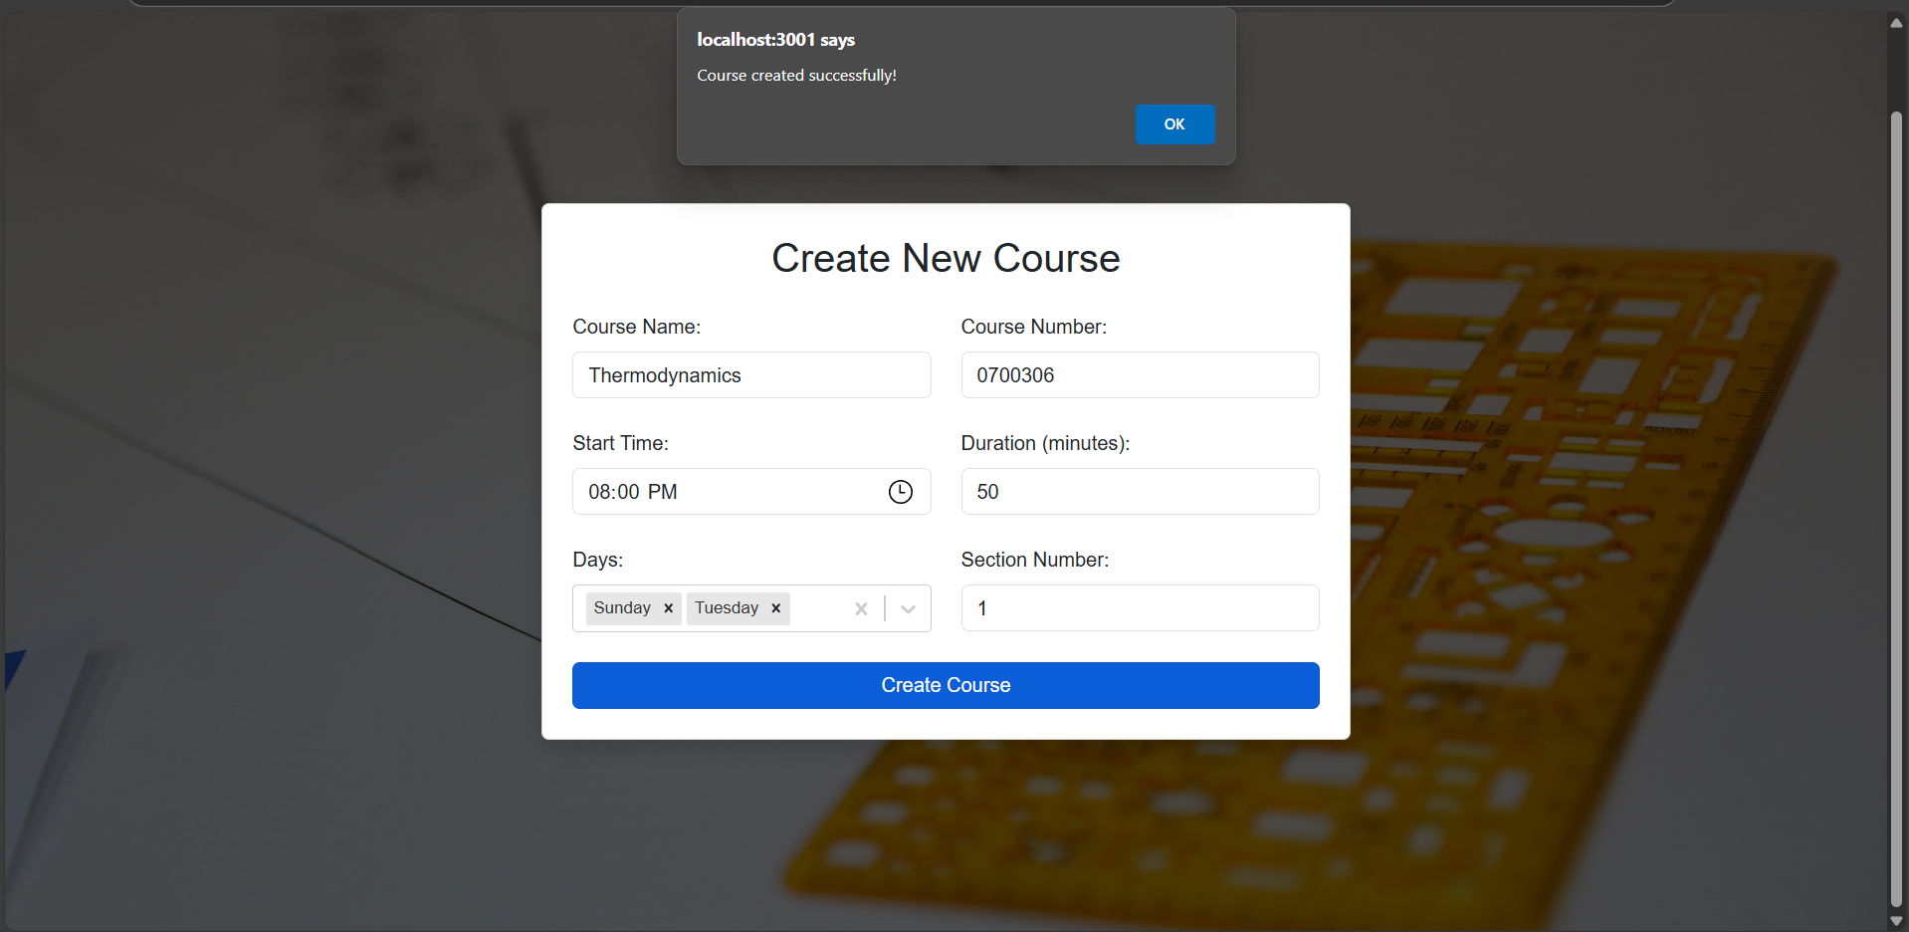

Add a new course

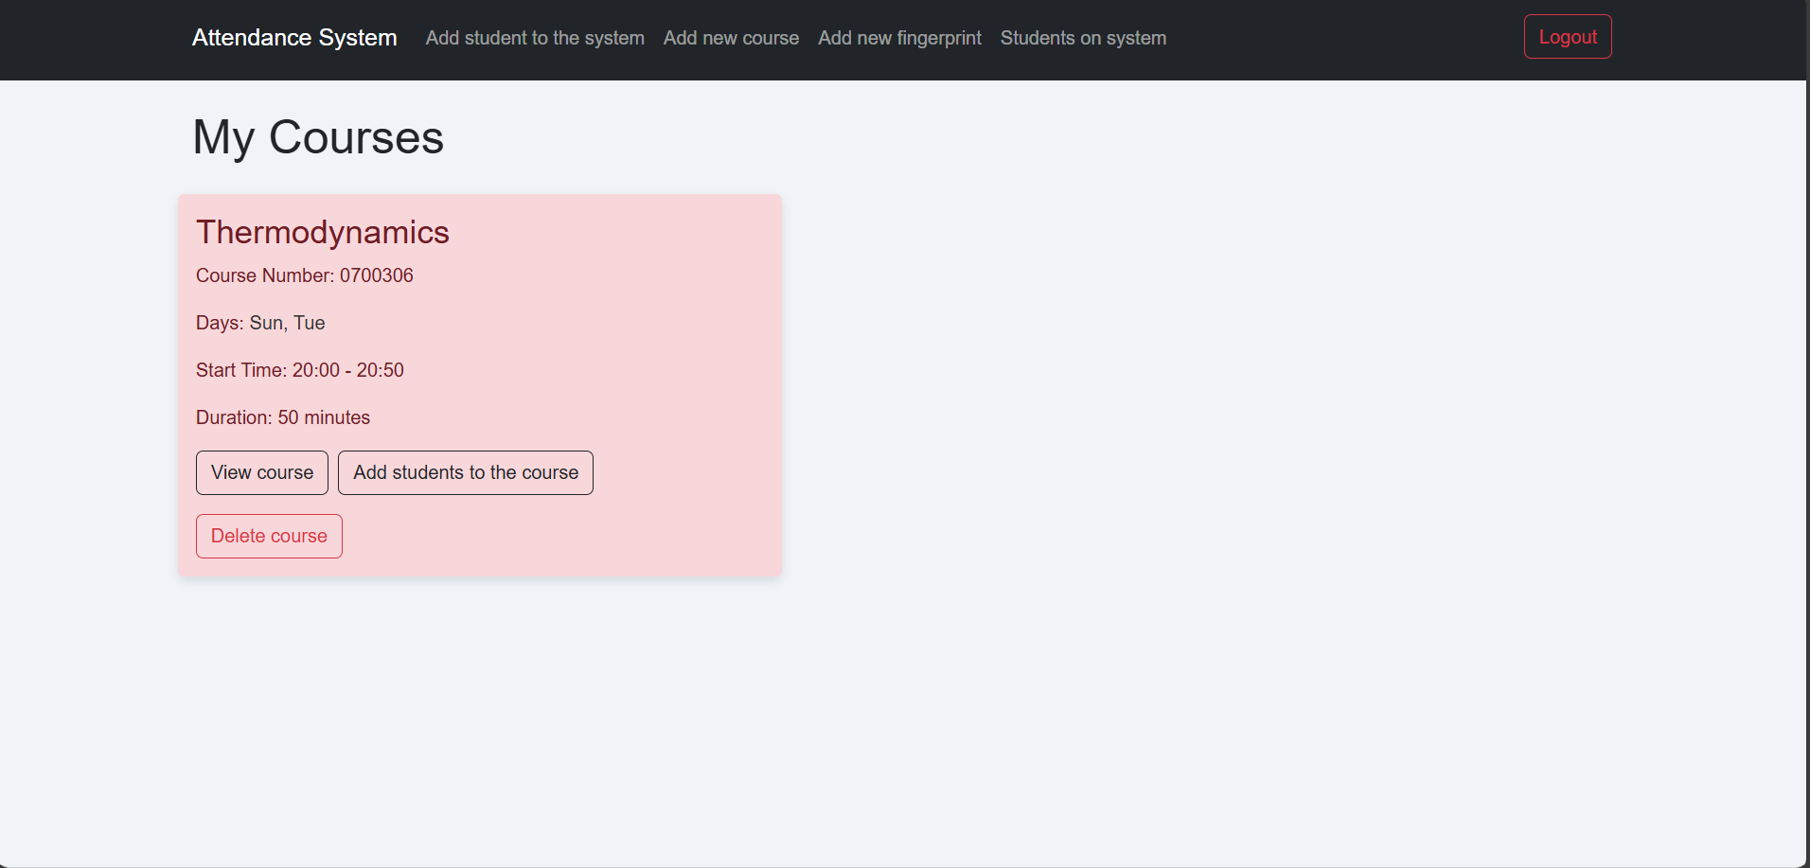

When the course is added successfully

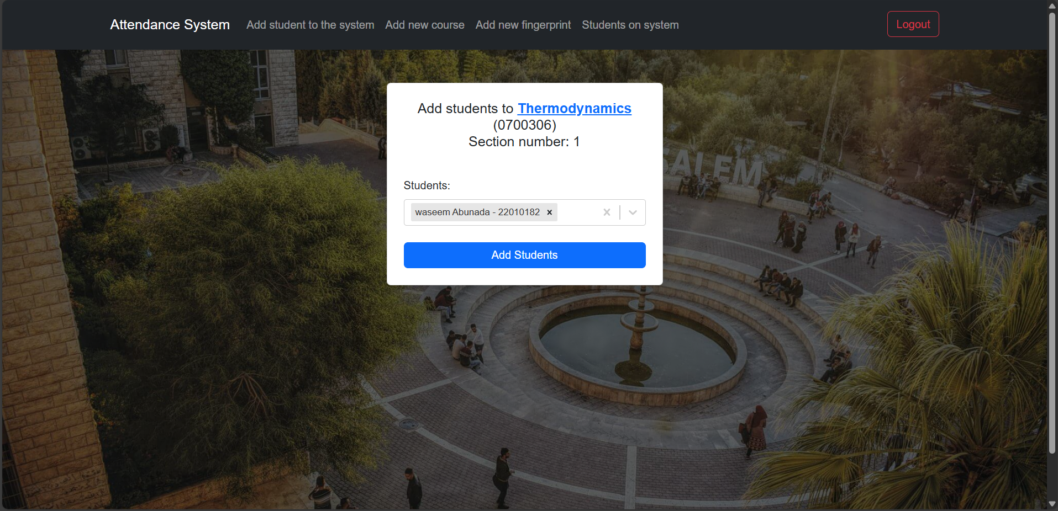

When entering the course, the students who will take this course are added from the list in which the students are registered in the system

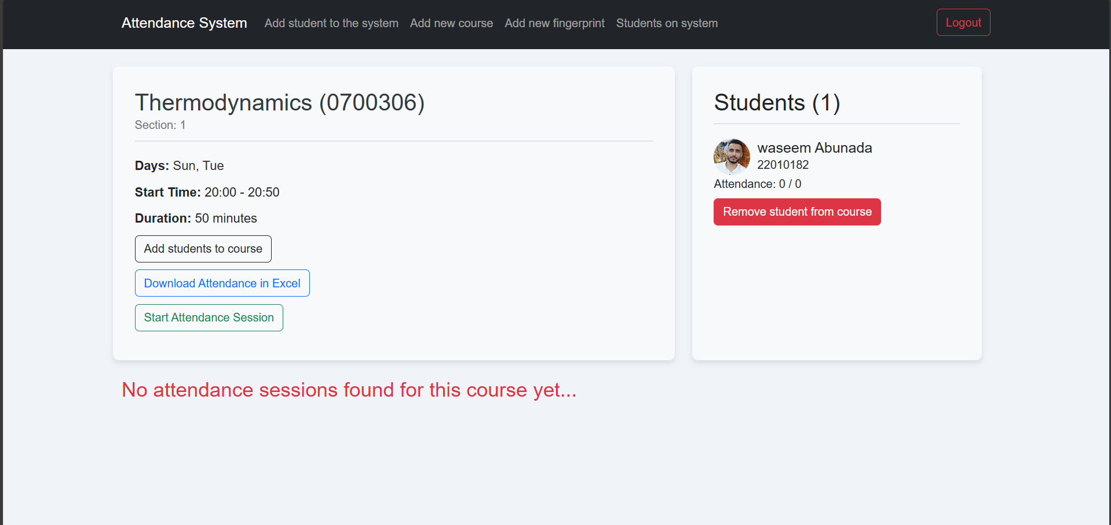

Students who are registered will appear inside the course

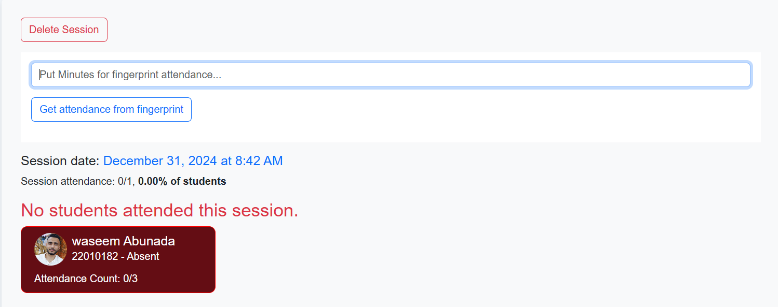

In case attendance is taken and the student is not present

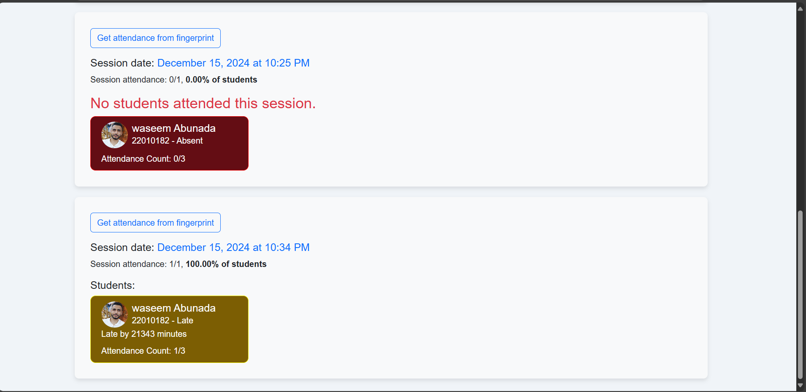

In the event that attendance is taken and the student is not identified, the fingerprint will be resorted to

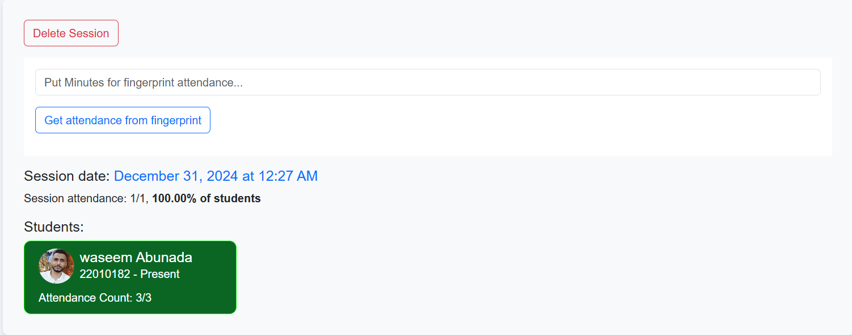

If the camera took attendance for the same student three times during the specified period

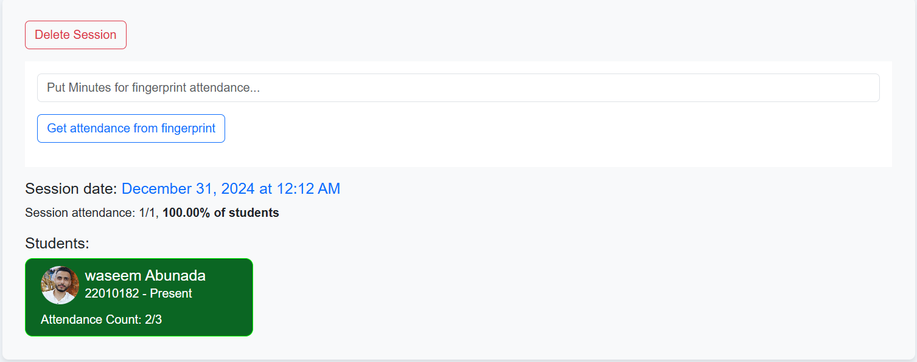

In the event that the number is incomplete, it means that the camera did not capture the student's face at one time or that the student left the lecture

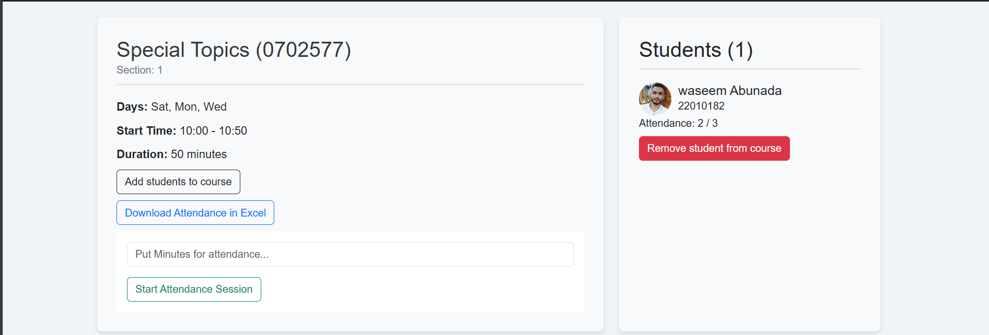

In the list of names, what was attended out of all lectures is counted.

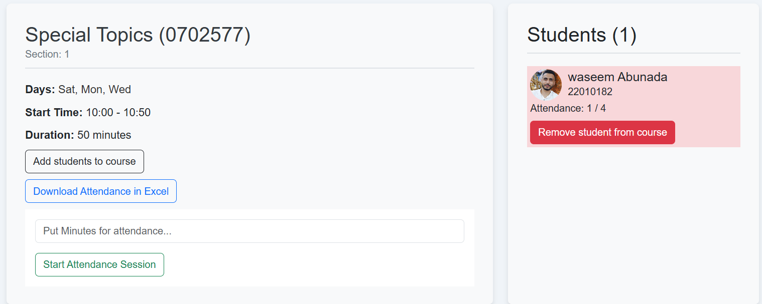

In the event that the student is absent three lectures according to the law, a red background will come above his name, which will be a warning to the lecturer

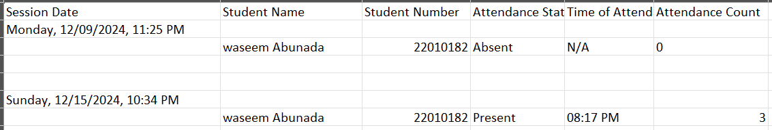

Attendance for all class is saved inside an excel file

**References**

* **Control your Arduino IoT projects with a MongoDB database**  
  A tutorial video showing how to link Arduino IoT projects to a MongoDB database, offering practical insight into the integration. <https://www.youtube.com/watch?v=a87dlq7pqB4>
* **Building a Facial Recognition System with React and OpenCV**  
  An article explaining how to build a facial recognition system using React and OpenCV, relevant for integrating an IP camera in your attendance system.

<https://medium.com/analytics-vidhya/face-recognition-login-using-reactjs-and-computer-vision-e98a892fd4ef>

* Implementing Fingerprint Authentication with Arduino A guide showing how to use a fingerprint sensor with Arduino for authentication, which is a key component of your project.

<https://www.instructables.com/Arduino-Fingerprint-Sensor-Tutorial/>

* **Bluetooth Communication between Arduino and Smartphone**  
  An article explaining how to achieve Bluetooth communication between Arduino and a smartphone, which can be useful for the user interface of your attendance system.

<https://www.instructables.com/Arduino-and-Mobile-Bluetooth-Communication-messeng/>

* **Developing a MERN Stack Application: MongoDB, Express, React, Node.js**  
  A comprehensive guide on developing applications with the MERN stack, relevant for building your web interface. <https://www.mongodb.com/resources/languages/mern-stack-tutorial>

<https://www.youtube.com/watch?v=O3BUHwfHf84&t=8092s>

* **Real-time Data Streaming with WebSockets in React**  
  A guide on implementing real-time data streaming with WebSockets in React, which can improve the interactivity of your user interface. [Learn how to implement it](https://developer.mozilla.org/en-US/docs/Web/API/WebSockets_API)
* **Peer, P., &amp; Solina, F. (1998). Automatic Detection of Human faces in images.**
* **GeeksforGeeks - I2C protocol**

<https://www.geeksforgeeks.org/i2c-communication-protocol/>

* **PlantUML - To create UML diagrams**

<https://planttext.com/>

* **DB Diagram - To create database schemas**

<https://dbdiagram.io/d/6768598bfc29fb2b3b1a9953>"

* **Lucidchart - To create charts**

<https://lucid.app/users/login#/login?folder_id=recent>